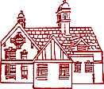
Disciplinary knowledge Art Curriculum
Kensington Junior Academy

Autumn
Year 3 | Year 4 | Year 5 | Year 6
Using Sketchbooks  - create sketch books to record their observations and use them to experiment and practice their ideas | Using Sketchbooks  - create sketch books to record their observations and use them to experiment and practice their ideas | Using Sketchbooks  - create sketch books to record their observations and use them to experiment and practice their ideas | Using Sketchbooks  - create sketch books to record their observations and use them to experiment and practice their ideas
What is a sketchbook for and how do we use it?  Build sketches and designs around a given criteria.  Use sketchbooks for rubbings to define texture  Make notes in a sketch book about techniques used by artists  Use a sketchbook to record media explorations and experimentations as well as try out ideas, plan colours and collect source material for future works.  Annotate ideas for improving their work through keeping notes in a sketchbook | Build sketches and designs around a given criteria.  Use sketchbooks for rubbings to define texture  Annotate pictures of Khalid Zaki’s work  Use sketchbooks to collect and record visual information from different sources as well as planning, trying out ideas, plan colours and collect source material for future works.  Express likes and dislikes through annotations  Explain how they are developing their ideas as they work, and are beginning to use language appropriate to the chosen style of art.  Keep notes to indicate their intentions/purpose of a piece of work | Build sketches and designs around a given criteria.  Annotate images of Anglo Saxon jewellery  Use sketchbooks to collect and record visual information from different sources as well as planning, trying out ideas, plan colours and collect source material for future works.  Use the sketch book to adapt work as and when necessary and explain why. Keep notes which consider how a piece of work may be developed further | Build sketches and designs around a given criteria.  Annotate images by Roman Halter  Record their thoughts and experiences in a sketch book and review and revisit these ideas as their work develops  Use sketchbooks to collect and record visual information from different sources as well as planning, trying out ideas, plan colours and collect source material for future works.  Use sketchbooks to plan through drawing and other preparatory work.  Confidently use language appropriate to the chosen art form, to help them to explain their ideas.  Keep notes which consider how a piece of work may be developed further

Paint – Cave paintings | Sculpture – Khalid Zaki | Sculpture 3d art Anglo Saxon jewellery | Drawing Roman Halter
Know tertiary colours  Further explore tint/tone shade- apply this in their paintings.  Create a background using a colourwash Use a range of brushes to create Shapes, textures, patterns & lines.  Use watercolour to produce washes for backgrounds and add detail  Identify the techniques used by different artists  Compare the work of different artists. -Recognise when art is from different cultures.  Recognise when art is from different historical periods | Sculpt using clay & other mouldable materials.  Include texture that conveys expression and/ or movement  Compare the work of different artists.  Recognise when art is from different cultures.  Recognise when art is influenced by different historical periods | Use tools to create texture and pattern Show life like qualities and real life proportions | Explain the different tools used to create art.  Explain personal choices of specific art techniques used.  Draw with precision using different  gradient pencils or other mediums for effect.  Show shape, proportion and perspective in drawings.
Inspiration from the greats | Inspiration from the greats | Inspiration from the greats | Inspiration from the greats
Cave art  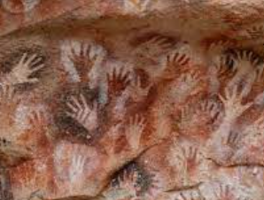  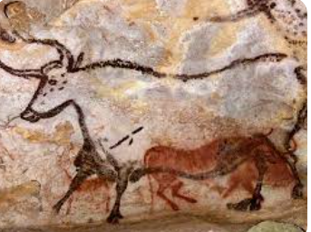 | Khalid Zaki  Egyptian sculptor Born 1964  Link to Egyptians topic and stylised paintings  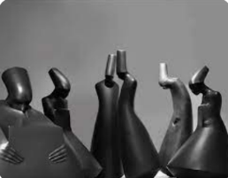  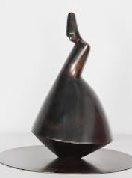 | Examples of Anglo Saxon Jewellery  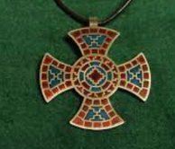  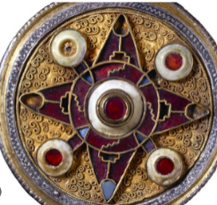 | Roman Halter  Polish painter 1927 – 2012  Link to WW2 topic  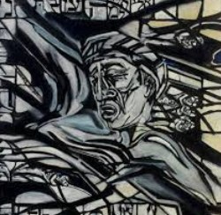  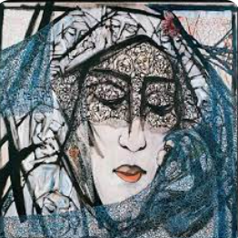

Spring
Year 3 | Year 4 | Year 5 | Year 6
Using Sketchbooks  - create sketch books to record their observations and use them to experiment and practice their ideas | Using Sketchbooks  - create sketch books to record their observations and use them to experiment and practice their ideas | Using Sketchbooks  - create sketch books to record their observations and use them to experiment and practice their ideas | Using Sketchbooks  - create sketch books to record their observations and use them to experiment and practice their ideas
Build sketches and designs around a given criteria.  Build facial features and proportions looking at different parts of the face  Practice gradient shading | Build sketches and designs around a given criteria.  Experiment with colour mixing  Annotate images by Vincent Van Gogh  Give a personal response to art | Build sketches and designs around a given criteria.  Experiment with acrylic paint to show its properties  Experiment with colour | Build sketches and designs around a given criteria.  Annotate images by Shamsia Hassani  Experiment with silhouettes and colour washes
Drawing – Frida Kahlo portraits | Paint - pointilism | Paint- Georgia o’keefe | Paint Graffiti Art Shamsia Hassani
Build on skills of tonal shading in their drawing.  Sketch lightly without using a rubber. Show facial expression in art.  Use sketches to help produce a final piece of art.  Use different grades of pencils to show tones and textures through hatching & cross hatching.  Use shading to show light & shadow. Annotate sketches to explain and elaborate. | Mix tertiary colours  Know how different colours affect our mood/feelings  Compare/contrast two paintings with separate moods.  Experiment with the styles used by other artists.  Explain some of the features of art from historical periods. | Use acrylic paint  Use tertiary colour in their paintings  Use the past as a source of artistic inspiration.  Experiment with mood & colour.  Sketch lightly before painting  Create a colour palette based on colours observed in natural world | Make individual choices regarding choice of media and state why in their work.  Research artwork from different periods of history and locations and investigate similarities and differences between the technique and styles used.  Explain the style of work produced and how a famous artist has influenced it. Use feedback to make amendments and improvements to art.  Create silhouettes/Colour washes
Inspiration from the greats | Inspiration from the greats | Inspiration from the greats | Inspiration from the greats
Frida Kahlo – self portrait – link to Mexico - spainish  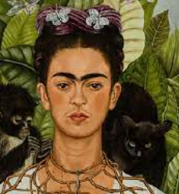  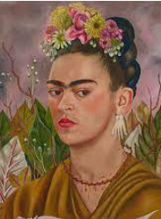 | Vincent van Gogh – pointillism – linked to rivers -  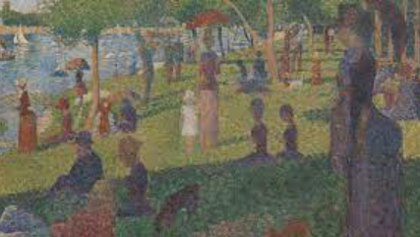 | Georgia O’Keefe – abstract. Flower art Link to biomes  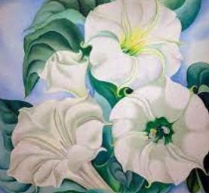  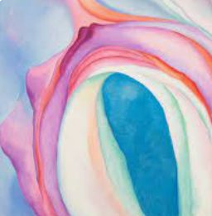 | Shamsia Hassani Afghanistan Islamic civilisation graffiti artist.  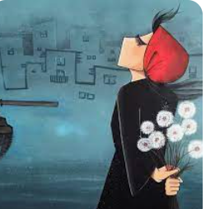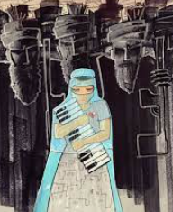
Summer
Year 3 | Year 4 | Year 5 | Year 6
Using Sketchbooks  - create sketch books to record their observations and use them to experiment and practice their ideas | Using Sketchbooks  - create sketch books to record their observations and use them to experiment and practice their ideas | Using Sketchbooks  - create sketch books to record their observations and use them to experiment and practice their ideas | Using Sketchbooks  - create sketch books to record their observations and use them to experiment and practice their ideas
Build sketches and designs around a given criteria.  Annotate pictures of Greek pots  Experiment with ancient Greek patterns and pictures | Build sketches and designs around a given criteria.  Annotate pictures of volcanoes by Turner and Warhol  Explain and justify their preference  Experiment with pencil to show movement | Build sketches and designs around a given criteria.  Experiment with proportion  Annotate images by Ernst Haeckel | Build sketches and designs around a given criteria.  Experiment with mixed media using photos, pictures and materials
Sculpture – Greek pots | Drawing Turner to Warhol | Drawing – Ernst Haeckel | Sculpture/ mixed media
Use clay.  Add materials to provide interesting details.  Use clay & other mouldable materials using coiling method.  Know that the ancient Greeks had a variety of different pots.  Know that Ancient Greek pots were decorated with patterns and pictures. | Begin to make individual choices in their choice of media.  Use line, tone, shape and colour to represent movement.  Use a variety of techniques to add effects e.g. reflections, shadow &  direction of sunlight.  Show reflections in art. | Begin to include measuring skills to help with proportion in their drawings.  Use shading to create mood and texture.  Use a variety of techniques to add effects e.g. reflections, shadow &  direction of sunlight.  Organise line, tone, shape and colour to represent figures and forms in movement.  Learn and use technical vocabulary.  Evaluate and analyse creative works | Know that mixed media means using a range of media to create different elements to a picture  Know that parts of photographs or prints can be used to create elements in a picture  Know that art can deliver important messages  Know that art can be used to influence others
Inspiration from the greats | Inspiration from the greats | Inspiration from the greats | Inspiration from the greats
Greek pottery  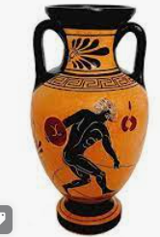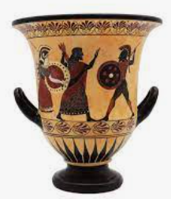 | JMW Turner and Andy Warhol’s representations of volcanic eruptions  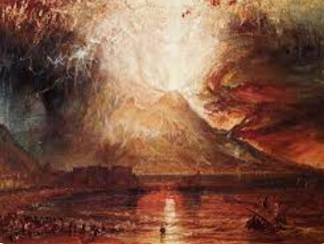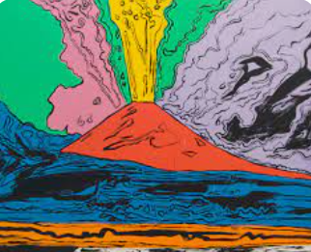 | Ernst Haeckel link to animals and living things from previous term and Victorians  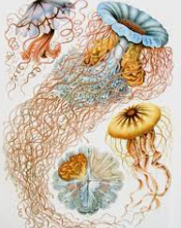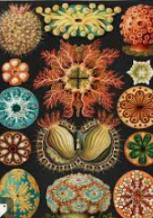 | John Sabraw/ Tan Zi Xi/ Olafur Eliasson all climate activist artists.  