


Parent/Carer SEND Handbook
2025/2026

Contents:

- Overview of SEND at Kensington Junior Academy
- Kensington Junior Academy’s Graduated Approach
- SEND Provision at Kensington Junior Academy
- Outside Agencies
- Useful Websites

Overview of Special Educational Needs
What are the 4 main areas of need for Special Educational Needs? | Cognition and Learning  Communication and Interaction  Social, emotional, and mental health  Sensory and or physical
Who is the Special Educational Needs Co-ordinator (SENDCo) at Kensington? | Vicky Powlson
How do I contact the SENDCo? | Ring or email the school office and request to speak to the SENDCo.
What should I do if I am concerned that my child might have a special Educational Need? | Initially, speak to your child’s class teacher about your concerns. It may be that the class teacher shares your concerns.  In addition to this, you can contact the SENDCo by ringing the school office.
What is Kensington Junior Academy’s SEND policy? | The SEND policy contains information relating to how we identify pupils with SEND and what provision we offer for children with SEND.
Where can I find Kensington’s SEND policy? | Kensington Junior Academy’s SEND policy can be found on our school website under the SEND tab.
What is the Local Offer? | The Local Offer provides information for children and young people with SEND and their parents or carers in a single place. It shows families what they can expect from a range of local agencies including education, health and social care.
Where can I find the Local Offer? | Derbyshire’s version of the Local Offer can be found by following the link Home - Derbyshire Local Offer

Overview of Special Educational Needs at Kensington Junior Academy

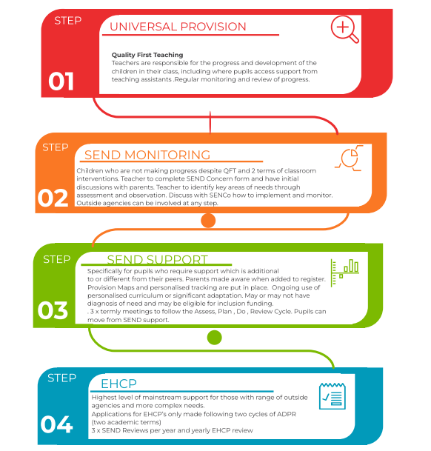

Step 1: Universal provision
-Quality first teaching delivers a multi-sensory approach to all curriculum areas for all children through different approaches, visual aids, and practical items to support learning
-Quality first teaching ensures appropriate and accurate adaptation to enable all children to access all areas of the curriculum and to move through the lesson’s success criteria
-Quality first teaching which provides an appropriate challenge to all pupils to ensure all children can make progress and move forwards with their learning
-A positive behaviour system is in place across the whole of school to encourage children to make the right choices and to receive consistent and fair consequences when making the wrong choices
-All teachers use a variety of resources both visual and practical to enable all children to demonstrate their knowledge and learning in a variety of ways
-Where appropriate, children are given ample thinking and response time
-Where appropriate, learning is broken down into chunks to make it accessible
-Where appropriate, children may have instructions repeated to them on an individual basis to ensure they have understood
Step 2: SEND Monitoring
-Small group support to further understanding, highlight misconceptions and close the gap
-Targeted intervention to boost progress and close the gap based on teacher assessments
-Specific intervention such as phonics, LSM and Number Sense
-Differentiated resources based on personal targets
-Referral to SALT services
-Individual assessment from an external agency
- May have a one-page profile on EDUkey

Step 3 and 4: SEND Support / EHCP
- Learning Plan on EDUkey
- Highly adapted activities and resources
- May have Individualised planning and specific targets
-Additional Assessments through Bsquared to show the small steps of progress being made
-Termly reviews with parents and class teachers to review and set individualised targets and to address any areas in need of further support
-Pockets of in class TA support
-Tailored provision, offering an alternative curriculum for children who cannot access their current curriculum/ provision

Kensington Junior Academy’s Graduated Approach

Any initial concerns can be raised with the class teacher at any time. Adaptations may then be put in place to support your child’s learning.
If after step one and two, there are still significant barriers to learning and they require support that is additional to and different from the majority of their peers they will be placed on SEND support.
The graduated response and Plan, Do, Review cycle will be followed as below.
Review
- After all the steps have been completed and they have been in action for a term you will have a phone call, or meeting, if appropriate, your child may also be invited to share their views and opinions.
- During the meeting, your child’s progress will be discussed. It will be decided if their targets have been met and new ones may be identified or adapted.
- Your child will have a pupil profile and a provision map of support. This will be updated every term and shared with yourselves.
Do
- This is where the provision will begin to enable your child to start meeting their targets.
- The provision will depend on your child’s individual needs and targets.
- If needed, as a school we would get support from outside agencies should you give us your consent.
- Staff will monitor the impact of their provision and adapt as necessary. They will also review your child’s targets.
Plan
- After your initial meetings with your child’s class teacher and or SENDCo, your child’s strengths and difficulties will have been identified. There will have been discussions around any strategies that have worked, any interests your child may have, and any barriers to learning.
- With all the above information, we would then design up to 3 SMART targets for your child, based around their area of need to reduce their barriers to learning.
Assess
- A meeting will be arranged to speak to your child’s teacher regarding any concerns that you may have about your child at home and/or school. This may include how you feel any behaviours are affecting their learning and progress. In this meeting, you may be able to identify any potential barriers.
- Secondly, a separate meeting with the SENDCo – Vicky Powlson may be arranged. They may be able to provide additional advice and support as well as log any concerns you are having as a parent/carer.

Outside agencies

In the Graduated Response, we will call on the support of external agencies. Depending on the child’s greatest need and barrier, we will select the most appropriate agency. Often the process will begin with an observation or assessment of the child and a parent consultation to ensure there is a full picture of the child’s needs in school and at home.
All outside agencies offer the following support:
- Observations
- Parent consultations
- Assessments
- Identifying barriers
- Support strategies
- Resources
- Training

Useful Special Educational Needs website links

Below are websites which have been recommended by outside agencies which school come into contact with on a regular basis.
Autism spectrum Disorder Team | https://www.autismspeaks.org/  https://www.autism-society.org/  Derbyshire Autism Services  Providing help and support to autistic people… | Autism East Midlands
Learning support Team | https://whiterosemaths.com/parent-workbooks/  SEND: guide for parents and carers - GOV.UK (www.gov.uk)  https://www.specialneedsjungle.com/distance-education-resources-for-children-and-young-people-with-send/  https://www.ucl.ac.uk/ioe/departments-and-centres/centres/ucl-centre-educational-leadership/free-online-learning-resources#Primary  https://www.thriveapproach.com/resources/
Behaviour, Social and Emotional Mental Health Team | https://www.verywellmind.com/social-and-emotional-development-in-early-childhood-2795106  Home - Kooth  SANEline services - SANE  https://www.understood.org/en/learning-thinking-differences/signs-symptoms/age-by-age-learning-skills/social-and-emotional-skills-what-to-expect-at-different-ages  https://www.understood.org/en/learning-thinking-differences/child-learning-disabilities/social-skills-issues/understanding-childs-trouble-with-social-skills?_ul=1*kdo9gm*domain_userid*YW1wLUJQQkF6NTYya3UtS0hwME93RWtqbEE.
Educational psychology Team | https://www.nhs.uk/using-the-nhs/nhs-services/mental-health-services/cypmhs-information-for-parents-and-carers/  https://youngminds.org.uk/find-help/for-parents/parents-guide-to-support-a-z/parents-guide-to-support-counselling-services/  https://www.annafreud.org/parents-and-carers/  https://www.youtube.com/channel/UCLhV-d1BFLFCLvCsgY8WlVA/videos

