
Eco-School Action Plan


Pupils need to take the lead in developing the Action Plan
Date Action Plan was developed: 4th April 2022
Action Plan developed by: The Eco Team

Topic | Target | Action/Measure | Timescale/ Deadline | Who is responsible? | Evaluation of action/  Actual result achieved
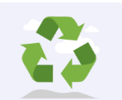  Waste | Teach the importance of the 5Rs. | -Assemblies run by the eco team to educate children on the importance of the 5Rs.  -Reduce the amount of paper wasted due to increased pupil/teacher understanding. | Summer 2024 | -Teachers, eco team, all children
Litter  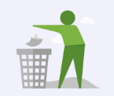 | Ensure that all waste goes in the correct bins and to the correct place, (all recyclable items are recycled). | -Accurate recycling bins for the staffroom.  -Children having a knowledge of which bins to use and using these accurately.  -Ensuring all staff are aware of the expectations to recycle. | Summer 2024 | SLT/ teaching staff/ eco team, all children
Litter | -To complete termly litter picks. | -A litter pick completed at least once a term, allowing us to get out into the community and make a difference to the local area. | Ongoing. | Eco team
Energy  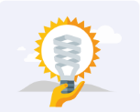 | To reduce school’s overall energy use. | -To monitor the energy used across school.  -For the eco-team to check lights, heating, screens, etc., are being used efficiently.  -For teacher’s to think about their energy use and reduce this where possible. | Summer 2024 | SLT/ teaching staff/ eco team
Biodiversity  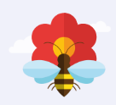 | Encourage more links to the outdoors. | -Increase opportunities for gardening.  -Increase opportunities for outdoor learning where links can be made to the National Curriculum.  -To link animals, plants and the outdoors to learning.  -To give children opportunities outdoors, eg; creating bug hotels. | Summer 2024 | SLT/ teaching staff

